DELHI PUBLIC SCHOOL LUDHIANA
RESULT HIGHLIGHTS AISSE [CLASS X] : Session 2024-25
SCHOOL TOPPERS

 | 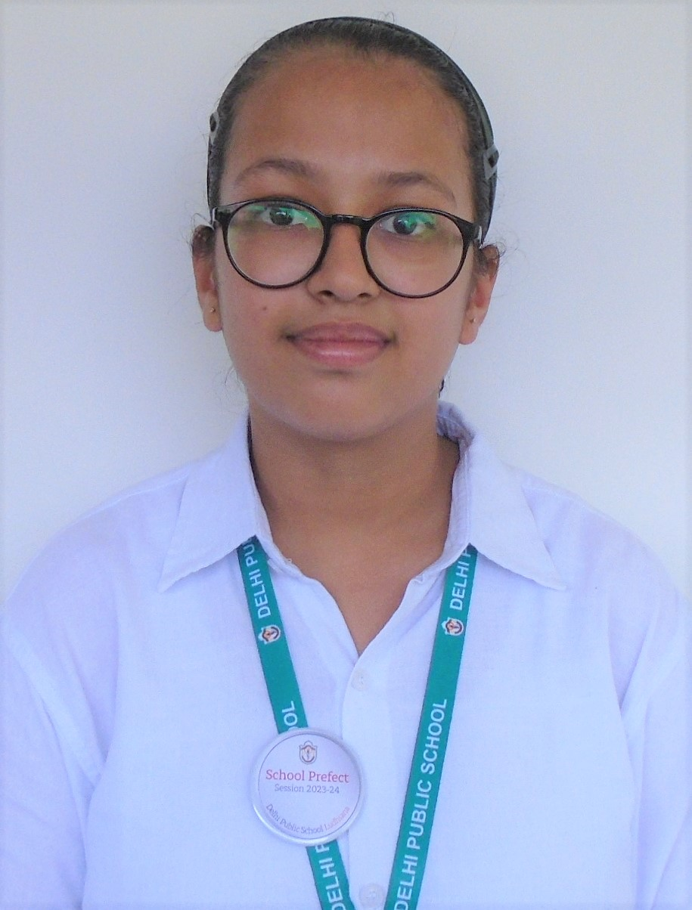 |  | 
TAPLEEN KAUR MAGGO  (97.8) | LAVANYA SINGLA  (97.6) | EKAAKSHAR GUPTA  (97) | SHREY JAIN  (97)

OVERALL PERFORMANCE OF THE SCHOOL
Particulars | Total No. | (%)
Students Appeared | 158 | -
Passed | 158 | 100.0
Failed | 0 | 0
Compartments | 0 | 0
Aggregate 90% & above | 45 | 28.5
Aggregate 80% to 89.9% | 56 | 35.4
Aggregate 70% to 79.9% | 31 | 19.6
Aggregate 60% to 69.9% | 16 | 10.1
Aggregate below 60% | 5 | 3.2
Students scoring 80% & above in Aggregate | 101 | 63.9
Students scoring Above 75% above in Aggregate (Distinctions) | 117 | 74.1

SUBJECT WISE MEAN ANALYSIS
SUBJECT | MEAN
ENGLISH | 85.6
HINDI | 82.1
PUNJABI | 88.1
MATHEMATICS – STANDARD | 83.7
MATHEMATICS – BASIC | 62.5
SCIENCE | 79.8
SOCIAL SCIENCE | 80.8
COMPUTER APPLICATIONS (6th Additional Subject) | 87.0
SCHOOL AVERAGE (Excluding 6th Additional Subject) | 82.2
SCHOOL AVERAGE (Including 6th Additional Subject) | 83.0

SUBJECT WISE DISTINCTIONS
SUBJECT | Appeared | Total Nos. of  Distinctions | (%)
ENGLISH | 158 | 143 | 90.5
HINDI | 87 | 67 | 77.0
PUNJABI | 71 | 66 | 93.0
MATHEMATICS – STD | 130 | 98 | 75.4
MATHEMATICS – BASIC | 28 | 6 | 21.4
SCIENCE | 158 | 108 | 68.4
SOCIAL SCIENCE | 158 | 118 | 74.7
COMPUTER APPLICATIONS | 158 | 140 | 88.6

SUBJECTWISE GRADE PERFORMANCE (STUDENTS WITH GRADES A1 OR A2)

SUBJECT | Appeared | Total Nos. of  A1 And A2 | (%)
ENGLISH | 158 | 58 | 36.7
HINDI | 87 | 33 | 37.9
PUNJABI | 71 | 23 | 32.4
MATHEMATICS – STD | 130 | 86 | 66.2
MATHEMATICS – BASIC | 28 | 18 | 64.3
SCIENCE | 158 | 85 | 53.8
SOCIAL SCIENCE | 158 | 64 | 40.5
COMPUTER APPLICATIONS | 158 | 61 | 38.6

TOPPERS
SCHOOL TOPPERS
Rank | Name of the student | %
1 | TAPLEEN KAUR MAGGO | 97.8
2 | LAVANYA SINGLA | 97.6
3 | EKAAKSHAR GUPTA, SHREY JAIN | 97
4 | EKAM SODHI | 96.8
5 | ARPITA RAI, JAYESHA JAIN, SHAHAAN SINGH SAHNI | 96.4
6 | ANSHIKA MAHAJAN | 96.2
7 | HARNIDH KAUR MAKKAR | 96
8 | VEDANT SINGH, SAANVI GUPTA | 95.8
9 | NAZAMPREET KAUR KOHLI, JIGARJEET KAUR AHUJA | 95.6
10 | ANISHKA SHARMA, TRIMAAN KAUR | 95.2

SUBJECT TOPPERS
Subject | Name of the student | %
ENGLISH | LAVANYA SINGLA, ANAHITAA JAIN | 99
HINDI | JAYESHA JAIN | 99
PUNJABI | JIGARJEET KAUR AHUJA, TAPLEEN KAUR MAGGO | 100
MATHEMATICS – STD | ANSHIKA MAHAJAN, NISHCHEY JINDAL, INAAYAT ASIJA | 100
MATHEMATICS – BASIC | AMAYRA VERMA | 85
SCIENCE | INAAYAT ASIJA, SHREY JAIN, VEDANT SINGH, EKAAKSHAR GUPTA, TAPLEEN KAUR MAGGO, SHAHAAN SINGH SAHNI, VIDISH GOYAL | 99
SOCIAL SCIENCE | EKAAKSHAR GUPTA, SHAHAAN SINGH SAHNI | 98
COMPUTER APPLICATIONS | DIVYANSHI MITTAL | 100

