DELHI PUBLIC SCHOOL LUDHIANA
RESULT HIGHLIGHTS AISSE [CLASS X] : Session 2023-24
SCHOOL TOPPERS

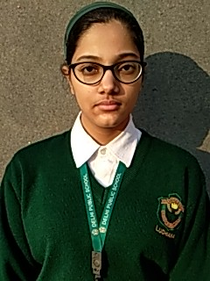 | 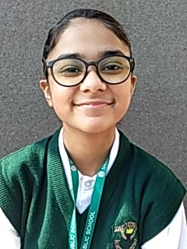 | 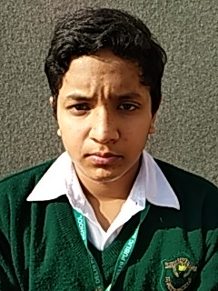 | 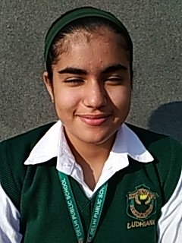
AARUSHI JINDAL (98.6) | MANNAT PAWAR (97.6) | RISHABH JAIN (97.6) | RYDHAM KAUR TOOR (97.4)

OVERALL PERFORMANCE OF THE SCHOOL
Particulars | Total No. | (%)
Students Appeared | 158 | -
Passed | 158 | 100.0
Failed | 0 | 0
Compartments | 0 | 0
Aggregate 90% & above | 60 | 38.0
Aggregate 80% to 89.9% | 58 | 36.7
Aggregate 70% to 79.9% | 29 | 18.4
Aggregate 60% to 69.9% | 10 | 6.3
Aggregate below 60% | 1 | 0.6
Students scoring 80% & above in Aggregate | 118 | 74.7
Students scoring Above 75% above in Aggregate (Distinctions) | 138 | 87.3

SUBJECT WISE MEAN ANALYSIS
SUBJECT | MEAN
ENGLISH | 86.5
HINDI | 84.8
PUNJABI | 94.3
MATHEMATICS – STANDARD | 88.2
MATHEMATICS – BASIC | 81.2
SCIENCE | 78.5
SOCIAL SCIENCE | 85.1
COMPUTER APPLICATIONS (6th Additional Subject) | 88.8
SCHOOL AVERAGE (Excluding 6th Additional Subject) | 85.2
SCHOOL AVERAGE (Including 6th Additional Subject) | 85.8

SUBJECT WISE DISTINCTIONS
SUBJECT | Appeared | Total Nos. of  Distinctions | (%)
ENGLISH | 158 | 150 | 94.9
HINDI | 96 | 83 | 86.5
PUNJABI | 62 | 62 | 100.0
MATHEMATICS – STD | 139 | 118 | 84.9
MATHEMATICS – BASIC | 19 | 11 | 57.9
SCIENCE | 158 | 106 | 67.1
SOCIAL SCIENCE | 158 | 134 | 84.8
COMPUTER APPLICATIONS | 158 | 142 | 89.9

SUBJECTWISE GRADE PERFORMANCE (STUDENTS WITH GRADES A1 OR A2)

SUBJECT | Appeared | Total Nos. of  A1 And A2 | (%)
ENGLISH | 158 | 61 | 38.6
HINDI | 96 | 36 | 37.5
PUNJABI | 62 | 44 | 71.0
MATHEMATICS – STD | 139 | 107 | 77.0
MATHEMATICS – BASIC | 19 | 18 | 94.7
SCIENCE | 158 | 91 | 57.6
SOCIAL SCIENCE | 158 | 81 | 51.3
COMPUTER APPLICATIONS | 158 | 87 | 55.1

TOPPERS
SCHOOL TOPPERS
Rank | Name of the student | %
1 | AARUSHI JINDAL | 98.6
2 | MANNAT PAWAR, RISHABH JAIN | 97.6
3 | RYDHAM KAUR TOOR | 97.4
4 | INAYA WADHWA | 96.6
5 | ABHINAV GUPTA | 96.0
6 | AMROZ KAUR GREWAL, UMANG BAWEJA, JASGUN KAUR | 95.8
7 | ISHLEEN KAUR, AGASTYA SAHGAL | 95.6
8 | INAYAT JAIRATH, YUVAN LOHIA | 95.2
9 | SVEA GUPTA | 94.6
10 | SHAURYA AGGARWAL, AKARSH AGGARWAL, PRIYAL SOOD, MANASVI JAIN | 94.2

SUBJECT TOPPERS
Subject | Name of the student | %
ENGLISH | AARUSHI JINDAL | 99
HINDI | INAYA WADHWA, ABHINAV GUPTA, AGASTYA SAHGAL, YUVAN LOHIA, SVEA GUPTA, MANASVI JAIN, SARAS MITTAL, SHIVEN KHULLAR, YASHVI AGGARWAL, EESHAN GUPTA, PRANAV KHULLAR, PRITIKA BAJAJ, NAIZA GOYAL, RIDHIMA GUPTA, MYRA GUPTA | 95
PUNJABI | AARUSHI JINDAL, MANNAT PAWAR, UMANG BAWEJA, JASGUN KAUR, MEHAKJOT KAUR, THAMISHTHA JAIN, VIHAAN GUPTA, TRIMAN KALSI | 100
MATHEMATICS – STD | RISHABH JAIN, RYDHAM KAUR TOOR, INAYA WADHWA, AKARSH AGGARWAL, PRIYAL SOOD, KUVAM JINDAL, YASHVI AGGARWAL | 100
MATHEMATICS – BASIC | THAMISHTHA JAIN, VIHAAN GUPTA | 99
SCIENCE | AARUSHI JINDAL | 100
SOCIAL SCIENCE | RYDHAM KAUR TOOR | 100
COMPUTER APPLICATIONS | AARUSHI JINDAL, YUVAN LOHIA, AKARSH AGGARWAL, AADEESH SINGLA, LOSHIMA KHANNA, HARSH JAIN, JANYA GABA, ANGEL DHAWAN | 99

