DELHI PUBLIC SCHOOL LUDHIANA
RESULT HIGHLIGHTS AISSE [CLASS X] : Session 2021-22
SCHOOL TOPPERS

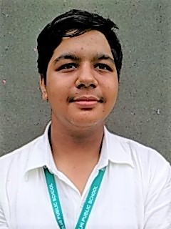 | 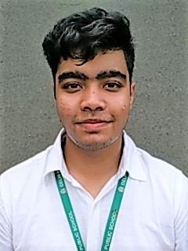 | 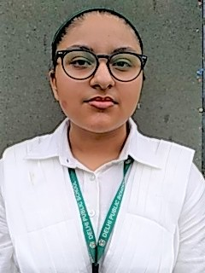
KRRISH SOOD (99.4 %) | SHIVAM GUPTA (98.2 %) | FALAK SAGAR (98 %)

OVERALL PERFORMANCE OF THE SCHOOL
Particulars | Total No. | (%)
Students Appeared | 170 | -
Passed | 170 | 100
Failed | 0 | 0
Compartments | 0 | 0
Aggregate 90% & above | 77 | 45.3
Aggregate 80% to 89.9% | 51 | 30
Aggregate 70% to 79.9% | 33 | 19.4
Aggregate 60% to 69.9% | 7 | 4.1
Aggregate below 60% | 20 | 11.8
Students scoring 80% & above in Aggregate | 128 | 75.3
Students scoring Above 75% above in Aggregate (Distinctions) | 149 | 87.6

SUBJECT WISE MEAN ANALYSIS
SUBJECT | MEAN
ENGLISH | 90.4
HINDI | 82.4
PUNJABI | 83.9
MATHEMATICS | 84.6
SCIENCE | 84.5
SOCIAL SCIENCE | 90.0
COMPUTER APPLICATIONS (6th Additional Subject) | 88.2
SCHOOL AVERAGE (Excluding 6th Additional Subject) | 86.6
SCHOOL AVERAGE (Including 6th Additional Subject) | 86.8

SUBJECT WISE DISTINCTIONS
SUBJECT | Appeared | Total Nos. of  Distinctions | (%)
ENGLISH | 170 | 163 | 95.9
HINDI | 62 | 52 | 83.9
PUNJABI | 108 | 87 | 80.6
MATHEMATICS | 170 | 131 | 77.1
SCIENCE | 170 | 132 | 77.6
SOCIAL SCIENCE | 170 | 156 | 91.8
COMPUTER APPLICATIONS | 170 | 152 | 89.4

SUBJECTWISE GRADE PERFORMANCE (STUDENTS WITH GRADES A1 OR A2)

SUBJECT | Appeared | Total Nos. of  A1 And A2 | (%)
ENGLISH | 170 | 134 | 78.8
HINDI | 62 | 19 | 30.6
PUNJABI | 108 | 39 | 36.1
MATHEMATICS | 170 | 127 | 74.7
SCIENCE | 170 | 109 | 64.1
SOCIAL SCIENCE | 170 | 132 | 77.6
COMPUTER APPLICATIONS | 170 | 104 | 61.2

TOPPERS

SCHOOL TOPPERS
Rank | Name of the student | %
1 | KRRISH SOOD | 99.4
2 | SHIVAM GUPTA | 98.2
3 | FALAK SAGAR | 98
4 | AVIYUSH SODHI | 97.6
5 | ADITYA CHOPRA, ARSHIA GOEL | 97.4
6 | SAKSHAM GOYAL, IRENE KAUR, VAANI AGGARWAL | 97.2
7 | JESSICA KAUR MAHENDRU | 97
8 | REHEB SINGH, VANSHIKA GABA, MANYA GROVER | 96.8
9 | SHREYA SINGLA, NANDINI GUPTA | 96.6
10 | SHIVEN PURI | 96.4

SUBJECT TOPPERS
Subject | Name of the student | %
ENGLISH | VAANI AGGARWAL, JESSICA KAUR MAHENDRU | 100
HINDI | KRRISH SOOD | 99
PUNJABI | ADITYA CHOPRA, SMARANDEEP SINGH | 99
MATHEMATICS | KRRISH SOOD, AVIYUSH SODHI, JESSICA KAUR MAHENDRU, REHEB SINGH, VANSHIKA GABA, SHIVEN PURI, DEVANSH MITTAL, KUNSH MEHRA, SANAH CHARAYA, AKSHITA MAHESHWARI, MANYA JAIN | 100
SCIENCE | KRRISH SOOD, ADITYA CHOPRA, ARSHIA GOEL, SAKSHAM GOYAL, RAHAB SINGH | 100
SOCIAL SCIENCE | AVIYUSH SODHI, IRENE KAUR, KAMAKSHI KAKAR | 100
COMPUTER APPLICATIONS | KRRISH SOOD, FALAK SAGAR, AVIYUSH SODHI, VAANI AGGARWAL, VANSHIKA GABA, KUNAL SOOD, HARSHAL JAIN, HARSHIT BRAR, INAYAT KAUR GREWAL | 100

