DELHI PUBLIC SCHOOL LUDHIANA
RESULT HIGHLIGHTS AISSE [CLASS X] : Session 2020-21
SCHOOL TOPPERS

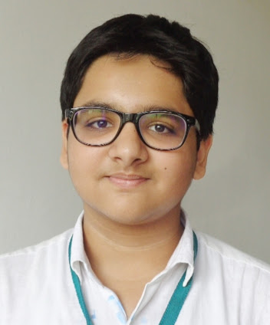 | 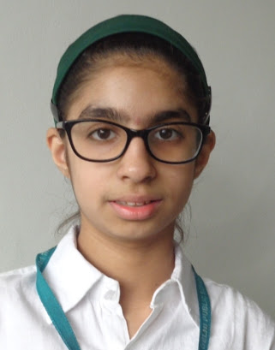 | 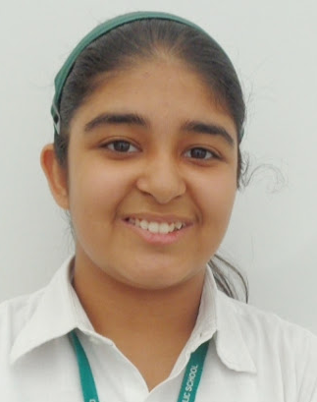 | 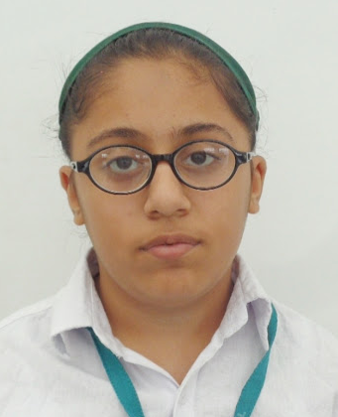
JAYADITYA MODGIL (97.7 %) | ANVVI S MALIK (97.5 %) | AASHI UPPAL (97.5 %) | DIYA CHAWLA (97.3 %)

OVERALL PERFORMANCE OF THE SCHOOL
Particulars | Total No. | (%)
Students Appeared | 151 | -
Passed | 151 | 100.0
Failed | 0 | 0.0
Compartments | 0 | 0.0
Aggregate 90% & above | 60 | 39.7
Aggregate 80% to 89.9% | 69 | 45.7
Aggregate 70% to 79.9% | 18 | 11.9
Aggregate 60% to 69.9% | 4 | 2.6
Aggregate below 60% | 0 | 0
Students scoring 80% & above in Aggregate | 129 | 85.4
Students scoring Above 75% above in Aggregate (Distinctions) | 140 | 92.7

SUBJECT WISE MEAN ANALYSIS
SUBJECT | MEAN
ENGLISH | 90.1
HINDI | 86.9
PUNJABI | 88.4
MATHEMATICS | 87.5
SCIENCE | 85.2
SOCIAL SCIENCE | 85.2
COMPUTER APPLICATIONS (6th Additional Subject) | 92.8
SCHOOL AVERAGE (Excluding 6th Additional Subject) | 87.1
SCHOOL AVERAGE (Including 6th Additional Subject) | 88.1

SUBJECT WISE DISTINCTIONS
SUBJECT | Appeared | Total Nos. of  Distinctions | (%)
ENGLISH | 151 | 147 | 97.4
HINDI | 75 | 71 | 94.7
PUNJABI | 76 | 73 | 96.1
MATHEMATICS | 151 | 141 | 93.4
SCIENCE | 151 | 131 | 86.8
SOCIAL SCIENCE | 151 | 139 | 92.1
COMPUTER APPLICATIONS | 151 | 151 | 100.0

SUBJECTWISE GRADE PERFORMANCE (STUDENTS WITH GRADES A1 OR A2)

SUBJECT | Appeared | Total Nos. of  A1 And A2 | (%)
ENGLISH | 151 | 120 | 79.5
HINDI | 75 | 33 | 44.0
PUNJABI | 76 | 49 | 64.5
MATHEMATICS | 151 | 121 | 80.1
SCIENCE | 151 | 115 | 76.2
SOCIAL SCIENCE | 151 | 57 | 37.7
COMPUTER APPLICATIONS | 151 | 94 | 62.3

TOPPERS

SCHOOL TOPPERS
Rank | Name of the student | %
1 | JAYADITYA MODGIL | 97.4
2 | ANVVI S MALIK, AASHI UPPAL | 97.2
3 | DIYA CHAWLA | 97
4 | ANANYA SALUJA, ARCHIT JINDAL | 96.6
5 | MAYANK PURI, SAMEEP SINGH | 96
6 | MAHITA JAIN | 95.8
7 | SIYA JAIN | 95.4
8 | AAKRITI BASSI, DIYA SHAH | 95.2
9 | ANNAMYA THAPAR, TANISHA DUA | 94.6
10 | AARAV POPLY, DEVANSH DHIR | 94.4

SUBJECT TOPPERS
Subject | Name of the student | %
ENGLISH | ANVVI S MALIK | 98
HINDI | ANANYA SALUJA, AASHI UPPAL | 99
PUNJABI | ANVVI S MALIK, JAYADITYA MODGIL, DIYA CHAWLA | 98
MATHEMATICS | ANVVI S MALIK, JAYADITYA MODGIL | 100
SCIENCE | DIYA CHAWLA | 100
SOCIAL SCIENCE | JAYADITYA MODGIL | 98
COMPUTER APPLICATIONS | JAYADITYA MODGIL, AASHI UPPAL, ANVVI S MALIK, ARCHIT JINDAL, ANANYA SALUJA, DIYA CHAWLA | 99

