DELHI PUBLIC SCHOOL LUDHIANA
RESULT HIGHLIGHTS AISSE : MARCH 2020 [CLASS X]

SCHOOL TOPPERS

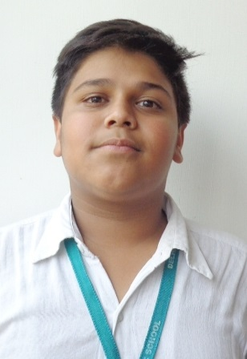 | 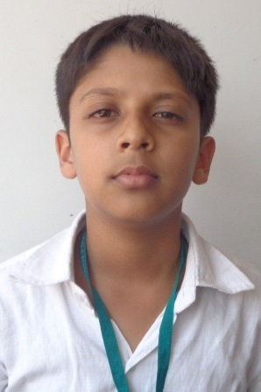 | 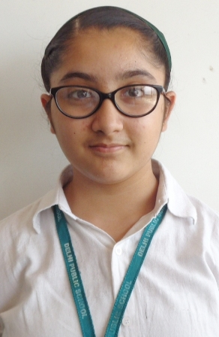
KANAV JAIN (98 %) | SAARTHAK GUPTA (96.8 %) | ISHLEEN KAUR KHURANA (96.6 %)

OVERALL PERFORMANCE OF THE SCHOOL
Particulars | Total No. | (%)
Students Appeared | 132 | -
Passed | 132 | 100.0
Failed | 0 | 0.0
Compartments | 0 | 0.0
Aggregate 90% & above | 54 | 40.9
Aggregate 80% to 89.9% | 57 | 43.2
Aggregate 70% to 79.9% | 16 | 12.1
Aggregate 60% to 69.9% | 5 | 3.8
Aggregate below 60% | 0 | 0.0
Students scoring 80% & above in Aggregate | 111 | 84.1
Students scoring Above 75% above in Aggregate (Distinctions) | 120 | 90.9

SUBJECT WISE MEAN ANALYSIS
SUBJECT | MEAN
ENGLISH | 90.5
HINDI | 86.6
PUNJABI | 89.7
MATHEMATICS | 83.1
SCIENCE | 79.4
SOCIAL SCIENCE | 90.9
COMPUTER APPLICATIONS (6th Additional Subject) | 95.8
SCHOOL AVERAGE (Excluding 6th Additional Subject) | 86.4
SCHOOL AVERAGE (Including 6th Additional Subject) | 88.0

SUBJECT WISE DISTINCTIONS
SUBJECT | Appeared | Total Nos. of  Distinctions | (%)
ENGLISH | 132 | 130 | 98.5
HINDI | 67 | 60 | 89.6
PUNJABI | 65 | 62 | 95.4
MATHEMATICS | 132 | 106 | 80.3
SCIENCE | 132 | 96 | 72.7
SOCIAL SCIENCE | 132 | 126 | 95.5
COMPUTER APPLICATIONS | 132 | 132 | 100.0

SUBJECTWISE GRADE PERFORMANCE (STUDENTS WITH GRADES A1 OR A2)

SUBJECT | Appeared | Total Nos. of  A1 And A2 | (%)
ENGLISH | 132 | 110 | 83.3
HINDI | 67 | 27 | 40.3
PUNJABI | 65 | 34 | 52.3
MATHEMATICS | 132 | 86 | 65.2
SCIENCE | 132 | 96 | 72.7
SOCIAL SCIENCE | 132 | 101 | 76.5
COMPUTER APPLICATIONS | 132 | 97 | 73.5

TOPPERS

SCHOOL TOPPERS
Rank | Name of the student | %
1 | KANAV JAIN | 98
2 | SAARTHAK GUPTA | 96.8
3 | ISHLEEN KAUR KHURANA | 96.6
4 | MENAZ GREWAL, TANISH SINGLA | 96.4
5 | TANISHA JAIN | 95.6
6 | EESHAN RALHAN, UDAI PRATAP SINGH MANGAT | 95.2
7 | VIDUSHI GARG, PUNEET CHAUDHARY | 94.8
8 | ANMOL SINGH WADHWA, JANVI SHARMA | 94.6
9 | GURNAAZ PANNU | 94.4
10 | DHRITI GARG, RABIYA GUPTA | 94.2

SUBJECT TOPPERS
Subject | Name of the student | %
ENGLISH | KANAV JAIN, VIDUSHI GARG, JANVI SHARMA, KHUSHBOO TREHAN, PRISHA JAIN, TWISHA JAIN, ANSH DAWAR, PUSHTI GUPTA | 98
HINDI | TANISHA JAIN | 99
PUNJABI | ANSHVIR SINGH GREWAL | 100
MATHEMATICS | TANISH SINGLA, SAARTHAK GUPTA, ARNAV GUPTA | 100
SCIENCE | ISHLEEN KAUR KHURANA | 98
SOCIAL SCIENCE | SAARTHAK GUPTA, MENAZ GREWAL, KANAV JAIN, ANMOL SINGH WADHWA, TANISH SINGLA, RUSHIL CHATLEY, TANISHA JAIN, ARBAAZ SINGH GREWAL | 100
COMPUTER APPLICATIONS | KANAV JAIN, TANISH SINGLA, TANISHA JAIN | 100

