DELHI PUBLIC SCHOOL LUDHIANA
RESULT HIGHLIGHTS AISSCE [Class XII] : Session 2021-22

SCHOOL TOPPERS – SCIENCE STREAM
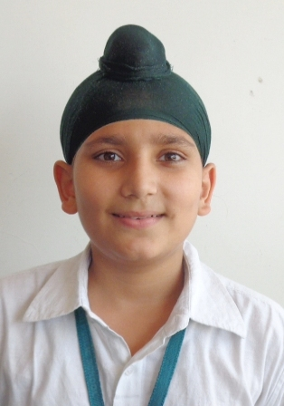 | 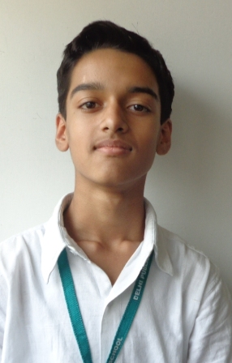 | 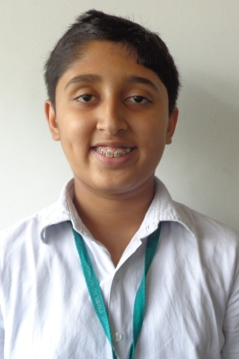 | 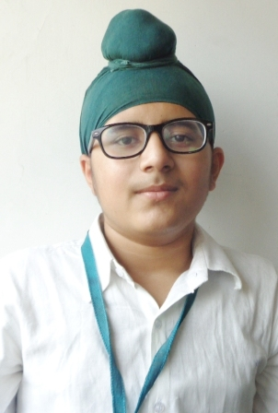
ANMOL SINGH WADHWA (95.4%) | PUNEET CHAUDHARY (95.4%) | PARTH SHARMA (93.6%) | GURMEET SINGH MATREJA (93.2%)

SCHOOL TOPPERS – COMMERCE STREAM
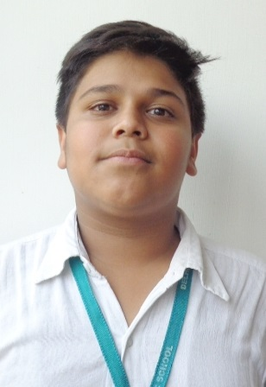 |  | 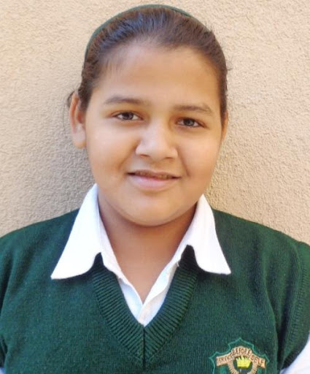 | 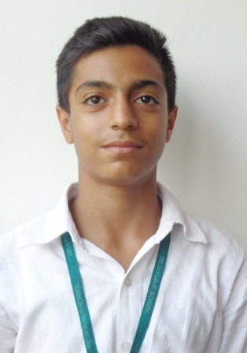
KANAV JAIN (97.6%) | ISHLEEN KAUR KHURANA (95%) | KHUSHBOO JAIN (95%) | ARADHYA KAPOOR (94.2%)



SCHOOL TOPPERS – HUMANITIES STREAM
 | 
PRACHI SETH (95.6%) | ASHMIT KUKRETI (91%) | AMAN CHOWDHARY (89%)

OVERALL PERFORMANCE OF THE SCHOOL
Particulars | Total No. | (%)
Students Appeared | 65 | -
Passed | 65 | 100
Failed | 0 | 0
Compartments | 0 | 0
Aggregate 90% & above | 21 | 32
Aggregate 80% to 89.9% | 30 | 46
Aggregate 70% to 79.9% | 11 | 17
Aggregate 60% to 69.9% | 3 | 5
Aggregate below 60% | 0 | 0
Students scoring 80% & above in Aggregate | 51 | 78
Students scoring Above 75% above in Aggregate (Distinctions) | 56 | 86

STREAM WISE PERFORMANCE OF THE SCHOOL

SCIENCE
S.NO. | PARTICULARS | FIGURES
1 | No. of students appeared | 14
2 | No. of students passed | 14
3 | No. of students passed in 1st division | 14
*4 | Students scoring 90% and above | 6
*5 | Students scoring 80% -89.9% | 5
* 6 | Students scoring 80% and above | 11
7 | Students scoring 70%-79.9% | 3
8 | Students scoring 60%-69.9% | 0
9 | Students scoring 50% - 59.9% | 0
10 | Total Distinctions ( in Aggregate ) | 12

COMMERCE
S.NO. | PARTICULARS | FIGURES
1 | No. of students appeared | 43
2 | No. of students passed | 43
3 | No. of students passed in 1st division | 43
*4 | Students scoring 90% and above | 13
*5 | Students scoring 80% -89.9% | 20
* 6 | Students scoring 80% and above | 33
7 | Students scoring 70%-79.9% | 8
8 | Students scoring 60%-69.9% | 2
9 | Students scoring 50% - 59.9% | 0
10 | Total Distinctions ( in Aggregate ) | 37

HUMANITIES
S.NO. | PARTICULARS | FIGURES
1 | No. of students appeared | 8
2 | No. of students passed | 8
3 | No. of students passed in 1st division | 8
*4 | Students scoring 90% and above | 2
*5 | Students scoring 80% -89.9% | 5
* 6 | Students scoring 80% and above | 7
7 | Students scoring 70%-79.9% | 0
8 | Students scoring 60%-69.9% | 1
9 | Students scoring 50% - 59.9% | 0
10 | Total Distinctions ( in Aggregate ) | 7

SUBJECT WISE MEAN ANALYSIS
SUBJECT | MEAN
ENGLISH | 87.8
PHYSICS | 79.8
CHEMISTRY | 83.6
MATHEMATICS | 87.7
APPLIED MATHEMATICS | 80.4
BIOLOGY | 89.6
ECONOMICS | 82.6
INFORMATICS PRACTICES | 87.1
BUSINESS STUDIES | 83.9
ACCOUNTANCY | 85.7
ENTREPRENEURSHIP | 93.3
PSYCHOLOGY | 86.3
HISTORY | 84.5
POLITICAL SCIENCE | 84.4
SOCIOLOGY | 85.7
SCHOOL AVERAGE | 85.1

SUBJECT WISE DISTINCTIONS
SUBJECT | Appeared | Total Nos. of  Distinctions | (%)
ENGLISH | 65 | 64 | 98.5
PHYSICS | 14 | 9 | 64.3
CHEMISTRY | 14 | 11 | 78.6
MATHEMATICS | 9 | 9 | 100.0
APPLIED MATHEMATICS | 26 | 20 | 76.9
BIOLOGY | 5 | 4 | 80.0
ECONOMICS | 44 | 35 | 79.5
INFORMATICS PRACTICES | 16 | 15 | 93.8
BUSINESS STUDIES | 43 | 36 | 83.7
ACCOUNTANCY | 43 | 33 | 76.7
ENTREPRENEURSHIP | 12 | 12 | 100.0
PSYCHOLOGY | 11 | 10 | 90.9
HISTORY | 8 | 7 | 87.5
POLITICAL SCIENCE | 8 | 6 | 75.0
SOCIOLOGY | 7 | 6 | 85.7

SUBJECTWISE GRADE PERFORMANCE (STUDENTS WITH GRADES A1 OR A2)

SUBJECT | Appeared | Total Nos. of  A1 And A2 | (%)
ENGLISH | 65 | 42 | 64.6
PHYSICS | 14 | 6 | 42.9
CHEMISTRY | 14 | 6 | 42.9
MATHEMATICS | 9 | 7 | 77.8
APPLIED MATHEMATICS | 26 | 13 | 50.0
BIOLOGY | 5 | 4 | 80.0
ECONOMICS | 44 | 28 | 63.6
INFORMATICS PRACTICES | 16 | 8 | 50.0
BUSINESS STUDIES | 43 | 19 | 44.2
ACCOUNTANCY | 43 | 30 | 69.8
ENTREPRENEURSHIP | 12 | 9 | 75.0
PSYCHOLOGY | 11 | 3 | 27.3
HISTORY | 8 | 6 | 75.0
POLITICAL SCIENCE | 8 | 6 | 75.0
SOCIOLOGY | 7 | 6 | 85.7

TOPPERS
SCHOOL TOPPERS
Rank | Name of the student | %
1 | KANAV JAIN | 97.6
2 | PRACHI SETH | 95.6
3 | ANMOL SINGH WADHWA | 95.4

SCIENCE TOPPERS
Rank | Name of the student | %
1 | ANMOL SINGH WADHWA | 95.4
2 | PUNEET CHAUDHARY | 95.4
3 | PARTH SHARMA | 93.6
4 | GURMEET SINGH MATREJA | 93.2

COMMERCE TOPPERS
Rank | Name of the student | %
1 | KANAV JAIN | 97.6
2 | ISHLEEN KAUR KHURANA | 95
3 | KHUSHBOO JAIN | 95
4 | ARADHYA KAPOOR | 94.2

HUMANITIES TOPPER
Rank | Name of the student | %
1 | PRACHI SETH | 95.6
2 | ASHMIT KUKRETI | 91
3 | AMAN CHOWDHARY | 89

SUBJECT TOPPERS
Subject | Name of the student | %
ENGLISH | ISHLEEN KAUR KHURANA | 97
PHYSICS | ARNAV GUPTA, PARTH SHARMA | 95
CHEMISTRY | PUNEET CHAUDHARY | 96
MATHEMATICS | GURMEET SINGH MATREJA | 96
APPLIED MATHEMATICS | KANAV JAIN | 100
BIOLOGY | ANMOL SINGH WADHWA | 99
ECONOMICS | KANAV JAIN | 97
INFORMATICS PRACTICES | GURMEET SINGH MATREJA | 100
BUSINESS STUDIES | DYUTIMA DHINGRA | 98
ACCOUNTANCY | KANAV JAIN, PRISHA JAIN | 100
ENTREPRENEURSHIP | KHUSHBOO JAIN | 99
PSYCHOLOGY | PRACHI SETH | 99
HISTORY | ASHMIT KUKRETI, PRACHI SETH | 94
POLITICAL SCIENCE | ASHMIT KUKRETI | 95
SOCIOLOGY | PRACHI SETH | 98

