DELHI PUBLIC SCHOOL LUDHIANA
RESULT HIGHLIGHTS AISSCE [Class XII] : Session 2020-21
SCHOOL TOPPERS – SCIENCE STREAM
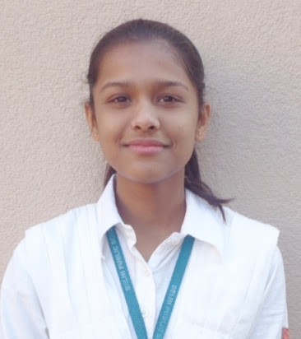 | 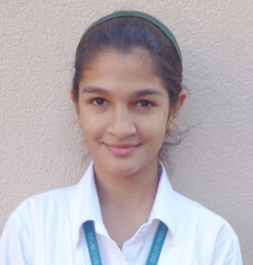 | 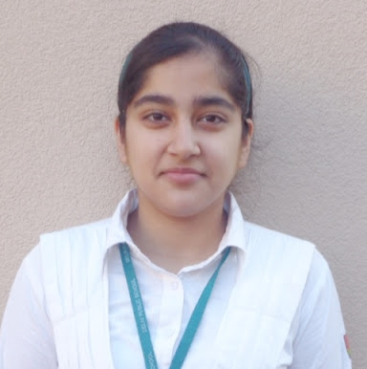
SANYA MALIK (97.6 %) | MEHAAK BHANDARI (97.2 %) | NAVNIDH KAUR (94.6 %)

SCHOOL TOPPERS – COMMERCE STREAM
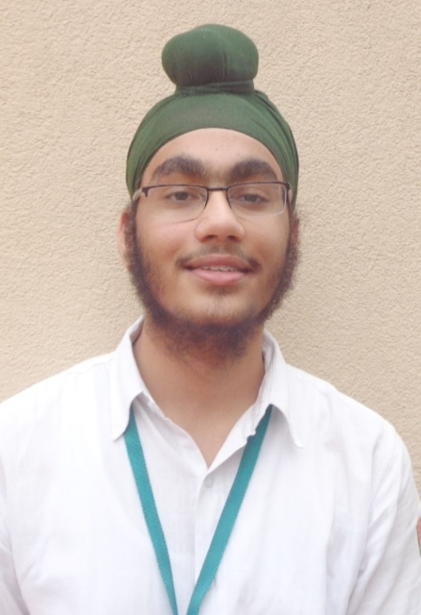 | 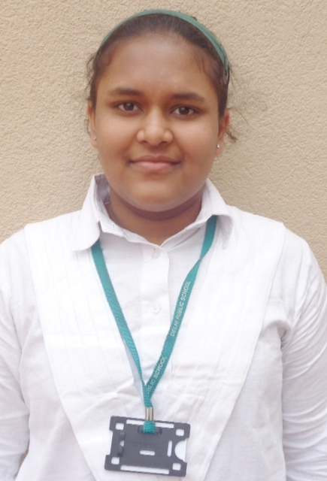 | 
HIMANAYA BAJAJ (98.8 %) | LAVISHA JAIN (98.4 %) | PULKIT MITTAL (97.8 %)

SCHOOL TOPPERS – HUMANITIES STREAM
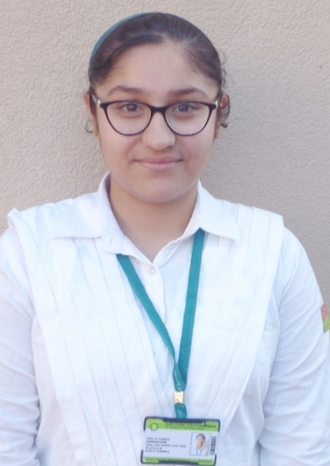 | 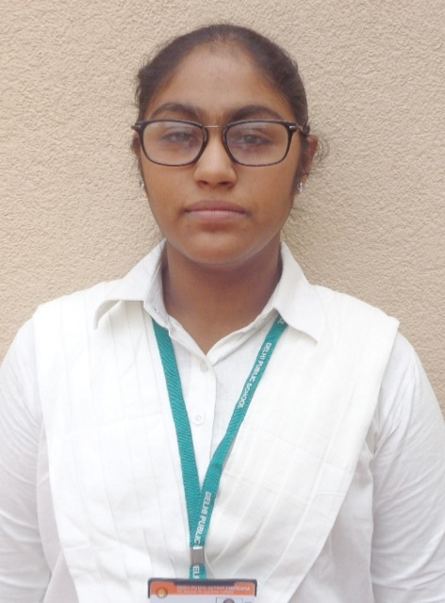 |  | 
GURNOOR KAUR (95.4 %) | KANAN JAIN (95.4 %) |  | SIMARPREET KAUR (95.4 %)
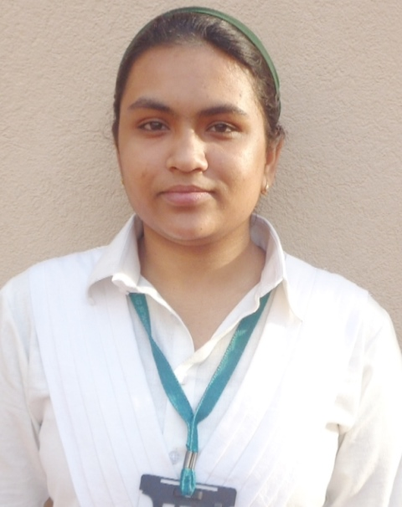 |  | 
ANADI MANGAT (94.4 %) |  | PRERNA GABA (92.6 %)

OVERALL PERFORMANCE OF THE SCHOOL
Particulars | Total No. | (%)
Students Appeared | 74 | -
Passed | 74 | 100
Failed | 0 | 0
Compartments | 0 | 0
Aggregate 90% & above | 66 | 89.2
Aggregate 80% to 89.9% | 8 | 10.8
Aggregate 70% to 79.9% | 0 | 0
Aggregate 60% to 69.9% | 0 | 0
Aggregate below 60% | 0 | 0
Students scoring 80% & above in Aggregate | 74 | 100
Students scoring Above 75% above in Aggregate (Distinctions) | 74 | 100

STREAM WISE PERFORMANCE OF THE SCHOOL

SCIENCE
S.NO. | PARTICULARS | FIGURES
1 | No. of students appeared | 14
2 | No. of students passed | 14
3 | No. of students passed in 1st division | 14
*4 | Students scoring 90% and above | 11
*5 | Students scoring 80% -89.9% | 3
* 6 | Students scoring 80% and above | 14
7 | Students scoring 70%-79.9% | 0
8 | Students scoring 60%-69.9% | 0
9 | Students scoring 50% - 59.9% | 0
10 | Total Distinctions ( in Aggregate ) | 14

COMMERCE
S.NO. | PARTICULARS | FIGURES
1 | No. of students appeared | 45
2 | No. of students passed | 45
3 | No. of students passed in 1st division | 45
*4 | Students scoring 90% and above | 40
*5 | Students scoring 80% -89.9% | 5
* 6 | Students scoring 80% and above | 45
7 | Students scoring 70%-79.9% | 0
8 | Students scoring 60%-69.9% | 0
9 | Students scoring 50% - 59.9% | 0
10 | Total Distinctions ( in Aggregate ) | 45

HUMANITIES
S.NO. | PARTICULARS | FIGURES
1 | No. of students appeared | 15
2 | No. of students passed | 15
3 | No. of students passed in 1st division | 15
*4 | Students scoring 90% and above | 15
*5 | Students scoring 80% -89.9% | 0
* 6 | Students scoring 80% and above | 15
7 | Students scoring 70%-79.9% | 0
8 | Students scoring 60%-69.9% | 0
9 | Students scoring 50% - 59.9% | 0
10 | Total Distinctions ( in Aggregate ) | 15

SUBJECT WISE MEAN ANALYSIS
SUBJECT | MEAN
ENGLISH | 91.8
PHYSICS | 93
CHEMISTRY | 87.4
MATHEMATICS | 93.4
BIOLOGY | 93
ECONOMICS | 93.4
INFORMATICS PRACTICES | 93
BUSINESS STUDIES | 94.1
ACCOUNTANCY | 93.8
ENTREPRENEURSHIP | 86.7
PSYCHOLOGY | 93.7
HISTORY | 92.9
POLITICAL SCIENCE | 93
SOCIOLOGY | 93.8
SCHOOL AVERAGE | 92.7

SUBJECT WISE DISTINCTIONS
SUBJECT | Appeared | Total Nos. of  Distinctions | (%)
ENGLISH | 74 | 74 | 100
PHYSICS | 14 | 14 | 100
CHEMISTRY | 14 | 14 | 100
MATHEMATICS | 30 | 30 | 100
BIOLOGY | 5 | 5 | 100
ECONOMICS | 49 | 49 | 100
INFORMATICS PRACTICES | 20 | 20 | 100
BUSINESS STUDIES | 45 | 45 | 100
ACCOUNTANCY | 45 | 45 | 100
ENTREPRENEURSHIP | 14 | 14 | 100
PSYCHOLOGY | 15 | 15 | 100
HISTORY | 15 | 15 | 100
POLITICAL SCIENCE | 15 | 15 | 100
SOCIOLOGY | 15 | 15 | 100

SUBJECTWISE GRADE PERFORMANCE (STUDENTS WITH GRADES A1 OR A2)

SUBJECT | Appeared | Total Nos. of  A1 And A2 | (%)
ENGLISH | 74 | 38 | 51.4
PHYSICS | 14 | 14 | 100.0
CHEMISTRY | 14 | 5 | 35.7
MATHEMATICS | 30 | 30 | 100.0
BIOLOGY | 5 | 3 | 60.0
ECONOMICS | 49 | 49 | 100.0
INFORMATICS PRACTICES | 20 | 15 | 75.0
BUSINESS STUDIES | 45 | 45 | 100.0
ACCOUNTANCY | 45 | 45 | 100.0
ENTREPRENEURSHIP | 14 | 2 | 14.3
PSYCHOLOGY | 15 | 6 | 40.0
HISTORY | 15 | 15 | 100.0
POLITICAL SCIENCE | 15 | 15 | 100.0
SOCIOLOGY | 15 | 15 | 100.0

TOPPERS
SCHOOL TOPPERS
Rank | Name of the student | %
1 | HIMANAYA BAJAJ | 98.8
2 | LAVISHA JAIN | 98.4
3 | PULKIT MITTAL | 97.8

SCIENCE TOPPERS
Rank | Name of the student | %
1 | SANYA MALIK | 97.6
2 | MEHAAK BHANDARI | 97.2
3 | NAVNIDH KAUR | 94.6

COMMERCE TOPPERS
Rank | Name of the student | %
1 | HIMANAYA BAJAJ | 98.8
2 | LAVISHA JAIN | 98.4
3 | PULKIT MITTAL | 97.8

HUMANITIES TOPPER
Rank | Name of the student | %
1 | GURNOOR KAUR, KANAN JAIN, SIMARPREET KAUR | 95.4
2 | ANADI MANGAT | 94.4
3 | PRERNA GABA | 92.6

SUBJECT TOPPERS
Subject | Name of the student | %
ENGLISH | HIMANAYA BAJAJ, MEHAAK BHANDARI | 99
PHYSICS | PRANAV VASUDEV | 97
CHEMISTRY | SANYA MALIK | 99
MATHEMATICS | PULKIT MITTAL | 100
BIOLOGY | SANYA MALIK | 99
ECONOMICS | HIMANAYA BAJAJ, LAVISHA JAIN, PULKIT MITTAL | 99
INFORMATICS PRACTICES | LAVISHA JAIN | 98
BUSINESS STUDIES | HIMANAYA BAJAJ | 99
ACCOUNTANCY | LAVISHA JAIN, HIMANAYA BAJAJ, MOHAK GUPTA | 99
ENTREPRENEURSHIP | PRAACHI JALAN | 95
PSYCHOLOGY | SANYA MALIK | 99
HISTORY | GURNOOR KAUR | 97
POLITICAL SCIENCE | SIMARPREET KAUR | 96
SOCIOLOGY | KANAN JAIN | 98

