DELHI PUBLIC SCHOOL LUDHIANA
RESULT HIGHLIGHTS AISSCE: MARCH 2020 [CLASS XII]

SCHOOL TOPPERS – SCIENCE STREAM
 |  | 
VINEET KAUR (98 %) | VINAMR JAIN (97.4 %) | DIVYAM SHUKLA (97.2 %)

SCHOOL TOPPERS – COMMERCE STREAM
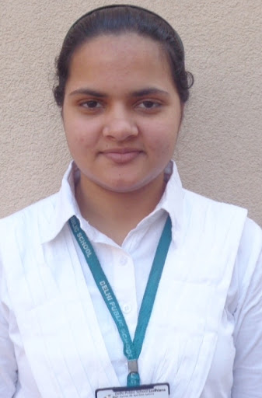 | 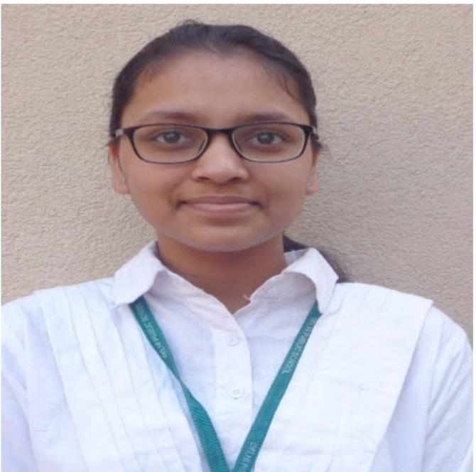 | 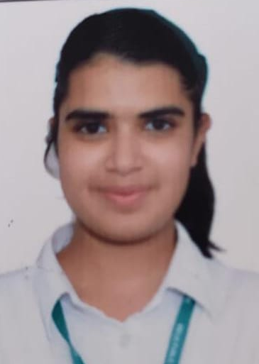
YASHIKA SHAH (98 %) | AKRITI AGGARWAL (97.6 %) | KASHISH JINDAL (96.4 %)

SCHOOL TOPPERS – HUMANITIES STREAM
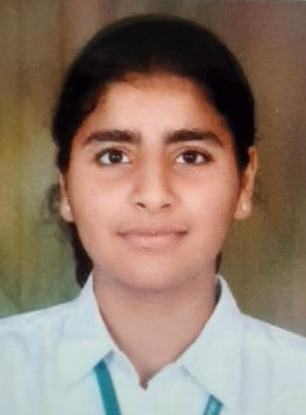 |  | 
HARVEER KAUR SANDHU (96.6 %) | AKSHAD BHAKOO (93.2 %) | JASNEET KAUR (91.8 %)

OVERALL PERFORMANCE OF THE SCHOOL
Particulars | Total No. | (%)
Students Appeared | 56 | -
Passed | 56 | 100
Failed | 0 | 0
Compartments | 0 | 0
Aggregate 90% & above | 36 | 64.3
Aggregate 80% to 89.9% | 16 | 28.3
Aggregate 70% to 79.9% | 3 | 5.3
Aggregate 60% to 69.9% | 1 | 1.8
Aggregate below 60% | 0 | 0
Students scoring 80% & above in Aggregate | 52 | 92.9
Students scoring Above 75% above in Aggregate (Distinctions) | 55 | 98.2

STREAM WISE PERFORMANCE OF THE SCHOOL

SCIENCE
S.NO. | PARTICULARS | FIGURES
1 | No. of students appeared | 19
2 | No. of students passed | 19
3 | No. of students passed in 1st division | 19
*4 | Students scoring 90% and above | 15
*5 | Students scoring 80% -89.9% | 4
* 6 | Students scoring 80% and above | 19
7 | Students scoring 70%-79.9% | 0
8 | Students scoring 60%-69.9% | 0
9 | Students scoring 50% - 59.9% | 0
10 | Total Distinctions ( in Aggregate ) | 19

COMMERCE
S.NO. | PARTICULARS | FIGURES
1 | No. of students appeared | 23
2 | No. of students passed | 23
3 | No. of students passed in 1st division | 23
*4 | Students scoring 90% and above | 17
*5 | Students scoring 80% -89.9% | 6
* 6 | Students scoring 80% and above | 23
7 | Students scoring 70%-79.9% | 0
8 | Students scoring 60%-69.9% | 0
9 | Students scoring 50% - 59.9% | 0
10 | Total Distinctions ( in Aggregate ) | 23

HUMANITIES
S.NO. | PARTICULARS | FIGURES
1 | No. of students appeared | 14
2 | No. of students passed | 14
3 | No. of students passed in 1st division | 14
*4 | Students scoring 90% and above | 4
*5 | Students scoring 80% -89.9% | 6
* 6 | Students scoring 80% and above | 10
7 | Students scoring 70%-79.9% | 3
8 | Students scoring 60%-69.9% | 1
9 | Students scoring 50% - 59.9% | 0
10 | Total Distinctions ( in Aggregate ) | 13

SUBJECT WISE MEAN ANALYSIS
SUBJECT | MEAN
ENGLISH | 94.1
PHYSICS | 85.7
CHEMISTRY | 94.5
MATHEMATICS | 88.8
BIOLOGY | 96.2
ECONOMICS | 91.3
INFORMATICS PRACTICES | 95.2
BUSINESS STUDIES | 93.6
ACCOUNTANCY | 90.7
ENTREPRENEURSHIP | 94.6
PSYCHOLOGY | 73.2
HISTORY | 85.9
POLITICAL SCIENCE | 77.8
SOCIOLOGY | 86.5
SCHOOL AVERAGE | 90.3

SUBJECT WISE DISTINCTIONS
SUBJECT | Appeared | Total Nos. of  Distinctions | (%)
ENGLISH | 56 | 56 | 100
PHYSICS | 19 | 16 | 84.2
CHEMISTRY | 19 | 19 | 100
MATHEMATICS | 26 | 23 | 88.5
BIOLOGY | 6 | 6 | 100
ECONOMICS | 30 | 29 | 96.7
INFORMATICS PRACTICES | 17 | 17 | 100
BUSINESS STUDIES | 23 | 23 | 100
ACCOUNTANCY | 23 | 22 | 95.7
ENTREPRENEURSHIP | 10 | 10 | 100
PSYCHOLOGY | 9 | 4 | 44.4
HISTORY | 14 | 12 | 63.2
POLITICAL SCIENCE | 14 | 9 | 64.3
SOCIOLOGY | 14 | 13 | 92.9

SUBJECTWISE GRADE PERFORMANCE (STUDENTS WITH GRADES A1 OR A2)

SUBJECT | Appeared | Total Nos. of  A1 And A2 | (%)
ENGLISH | 56 | 49 | 87.5
PHYSICS | 19 | 14 | 73.7
CHEMISTRY | 19 | 19 | 100.0
MATHEMATICS | 26 | 19 | 73.1
BIOLOGY | 6 | 5 | 83.3
ECONOMICS | 30 | 27 | 90.0
INFORMATICS PRACTICES | 17 | 17 | 100.0
BUSINESS STUDIES | 23 | 23 | 100.0
ACCOUNTANCY | 23 | 20 | 87.0
ENTREPRENEURSHIP | 10 | 9 | 90.0
PSYCHOLOGY | 9 | 0 | 0.0
HISTORY | 14 | 9 | 64.3
POLITICAL SCIENCE | 14 | 4 | 28.6
SOCIOLOGY | 14 | 10 | 71.4

TOPPERS
SCHOOL TOPPERS
Rank | Name of the student | %
1 | VINEET KAUR, YASHIKA SHAH | 98
2 | AKRITI AGGARWAL | 97.6
3 | VINAMR JAIN | 97.4

SCIENCE TOPPERS
Rank | Name of the student | %
1 | VINEET KAUR | 98
2 | VINAMR JAIN | 97.4
3 | DIVYAM SHUKLA | 97.2

COMMERCE TOPPERS
Rank | Name of the student | %
1 | YASHIKA SHAH | 98
2 | AKRITI AGGARWAL | 97.6
3 | KASHISH JINDAL | 96.4

HUMANITIES TOPPER
Rank | Name of the student | %
1 | HARVEER KAUR SANDHU | 96.6
2 | AKSHAD BHAKOO | 93.2
3 | JASNEET KAUR | 91.8

SUBJECT TOPPERS
Subject | Name of the student | %
ENGLISH | ANGELPREET KAUR CHAUHAN, VINEET KAUR, AKRITI AGGARWAL, SEERAT BHATIA | 99
PHYSICS | AVNEET CHEEMA, DIVYAM SHUKLA, KARKIRAT SINGH GILL, MANJOT SINGH OBEROI, RITVIK GUPTA, VINAMR JAIN, VINEET KAUR | 95
CHEMISTRY | MANJOT SINGH OBEROI, VINEET KAUR | 99
MATHEMATICS | AVNEET CHEEMA | 100
BIOLOGY | DIVYAM SHUKLA | 99
ECONOMICS | YASHIKA SHAH | 100
INFORMATICS PRACTICES | VINEET KAUR | 99
BUSINESS STUDIES | AKRITI AGGARWAL, YASHIKA SHAH | 98
ACCOUNTANCY | YASHIKA SHAH | 99
ENTREPRENEURSHIP | PRABLEEN KHURANA | 99
PSYCHOLOGY | ANGELPREET KAUR CHAUHAN | 92
HISTORY | HARVEER KAUR SANDHU | 99
POLITICAL SCIENCE | HARVEER KAUR SANDHU | 96
SOCIOLOGY | HARVEER KAUR SANDHU | 98

