Dear Parents
Pranam!
This is to inform you that for the Academic Session 2026–2027, the preferred shoe brands for the students' uniform are Action or Liberty, in black colour, as per the approved design.
Please note the following specifications:
- Classes VI to XII: Shoes with laces
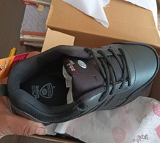
You may choose either of the two mentioned brands for your ward, ensuring that the design and colour match the approved sample provided for reference.
Thank you and regards
SPS MV

